Part No.：PT513B-BO1 UNIT：mm
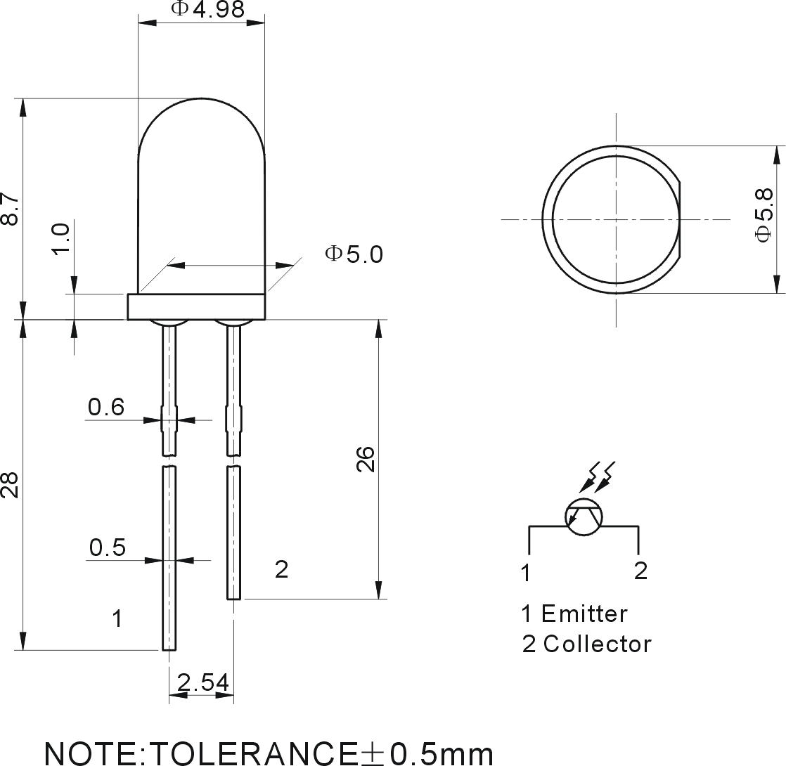
Parameter | Symbol | MIN. | TYP. | MAX. | UNIT | TEST CONDITION
Reverse dark current | I_{CEO} |  |  | 100 | nA | VCE=10V
C-E Saturation Voltage | V_{CE (Sat)} |  |  | 300 | mV | IC=5mA IB=1mA
Light Current | Ic(on) | 200 |  | 1500 | uA | VCE=10V IC=1mA
Rise Time(10％to90％) | t_{r} |  | 15 |  | uS | Vce=5V Ic=1mA
Fail Time(90％to10％) | t_{j} |  | 15 |  | uS | R_{L}=100ohms
Wavelength of Peak Sensitivity | λp |  | 940 |  | nm
Range of Spectral Bandwidth | λ_{0.5} | 700 |  | 1200 | nm
Collector-Emitter Voltage | BV_{CEO} | 40 |  |  |  | ICE=500uA
Collector-Base Voltage | BV_{CBO} | 50 |  |  |  | ICB=50uA
Emitter- Base Voltage | BV_{EBO} | 6 |  |  |  | IEB=50uA
Emitter-Collector Voltage | BV_{ECO} | 5 |  |  |  | IEC=50uA
Collector Current | I_{C} |  | 20 |  | mA
C-Power dissipation | P_{C} |  | 100 |  | mW
■ ABSOLUTE MAXIMUM RATINGS: (Ta=25℃)
- OPERATING TEMPERATURE: -25℃ TO +85℃
- LEAD SOLDERING TEMPERATURE: 260℃ FOR 5 SECONDS

